

**SEVEN WOMEN DOCUMENTARY**

**‘HOST A SCREENING’**

**PACK**

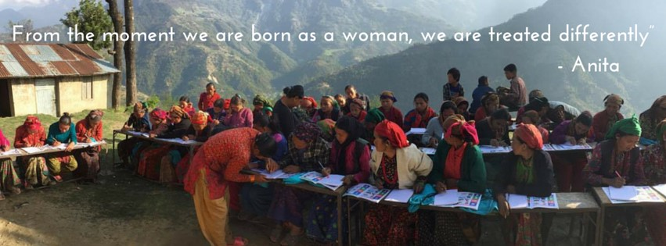

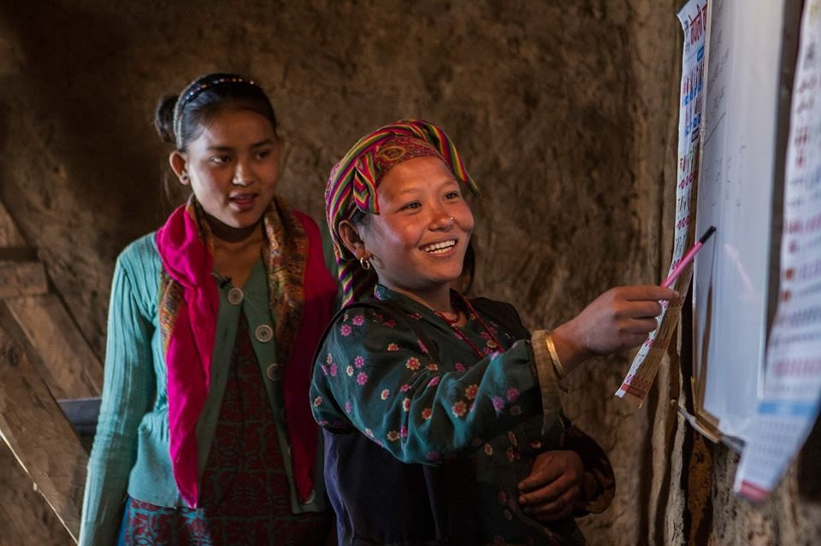

**Resources**

* Seven Women - Website - [http://www.sevenwomen.org](http://sevenwomen.org/" \t "_blank)
* Seven Women - Facebook - [https://www.facebook.com/SevenWomenStore/](https://www.facebook.com/SevenWomenStore/" \t "_blank)
* Seven Women - Donations - <http://sevenwomen.org/donations.html>
* Hands on Development Website - [https://www.handsondevelopment.com.au](https://www.handsondevelopment.com.au/" \t "_blank)
* Hands on Development Facebook -[https://www.facebook.com/HandsOnDevelopmentEducationalToursToNepal/](https://www.facebook.com/HandsOnDevelopmentEducationalToursToNepal/" \t "_blank)
* Email: info@seven-women.com

**Host a Screening Pack Contents­:**

* Introduction
* A Note from the Producer
* Aims of Seven Women Documentary Screenings
* Step 1: Organising Your Event
* Step 2: Promoting Your Event
* Step 3: Preparation and Follow-Up
* Share your feedback
* Example Running Sheet

# **Introduction**

**Why a documentary screening event?**

Filmed over a period of four years, this film follows a group of Nepalese women whose lives have been empowered through education, skills training and income generation. This is a story of courage, resilience and strength as these women seek to create a better life for themselves, their families, and other women in Nepal.

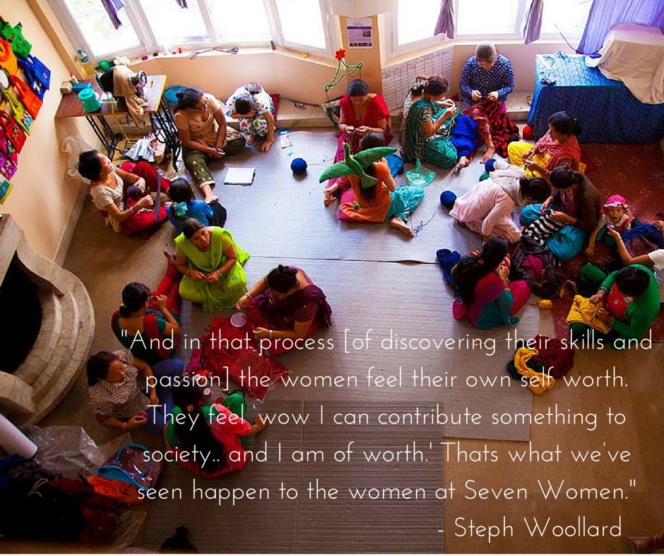

A film event is simple and straightforward to organise, and it can be any size! In this pack we will be giving you some background to the film and the organisation Seven Women as well as guidance as to how to host a successful film event.

We follow the stories of several women involved with the organisation – each representing the different challenges women face in Nepalese society – domestic violence, discrimination, lack of education, poverty, young marriage, risk of human trafficking and exploitation.

You are invited to host a film event to raise awareness and encourage people to take action to end trafficking in the fashion industry.

# **A Note from the Producers**

The life of a Nepalese woman is beset with challenges. Raised in a patriarchal society, they are seen as second-rate citizens. The majority of women have been exposed to domestic violence, over 50% are illiterate, and over 7,000 girls and women are trafficked abroad every year.

Stephanie Woollard, a young Australian social entrepreneur, was moved by the plight of seven disabled women she met who were working out of a tin shed in Kathmandu. They were struggling to make a living and enduring harsh discrimination for their disabilities. She founded the fair-trade organisation Seven Women in 2006 to empower marginalized women. They have since trained and employed over 5000 women, who have gone on to have ripple effects in their communities sharing the skills they have learnt.

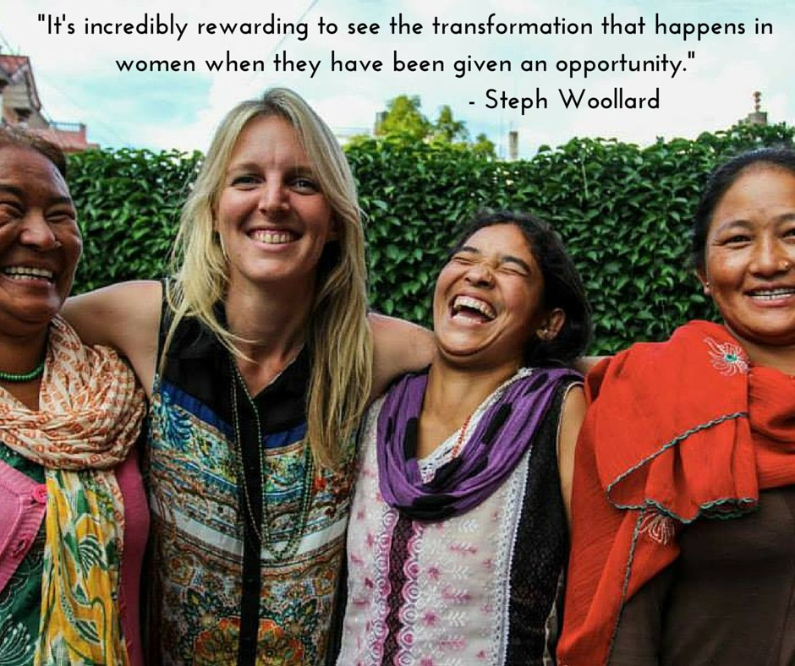

# **Aims of Seven Women Documentary Screenings**

**This film shows that real and lasting change is possible, when humans unite to stand up to** **injustice.** It examines civic courage, as each character challenges what society dictates they are capable of doing.

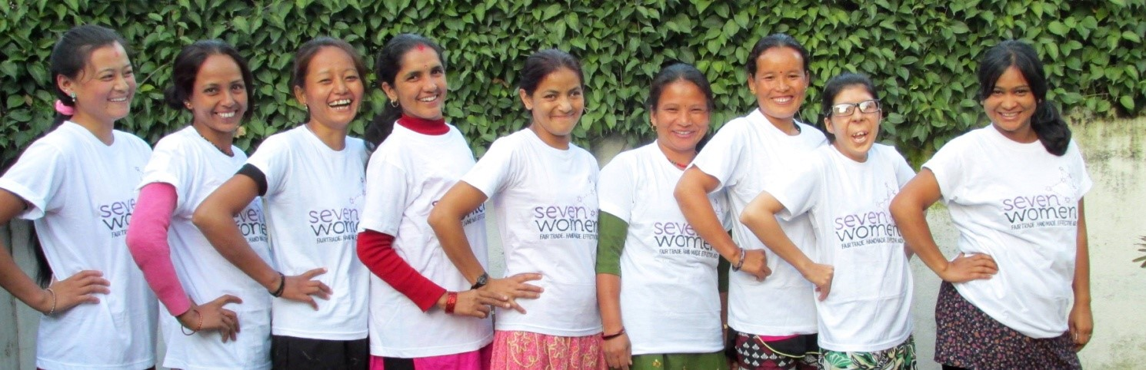

We believe this documentary will have an important message to share that will influence people to think about charity differently.

**Our aims:**

1. To educate others on the empowerment model of development.
2. To develop tolerance and understanding of difference through the main characters and their stories.
3. To highlight the importance of educating and empowering women.
4. To raise awareness of fair trade and guide consumers to be more conscious of buying choices and understand the direct impact our consumerism can have on another. We will do this by offering fair trade products made by the women in Nepal at the end of our screening
5. To raise awareness of the work of Seven Women and adopt more support in reaching their goal of impacting the lives of over 100,000 women by the year 2025 in Nepal.

For more information about the film visit [http://www.sevenwomen.org](http://sevenwomen.org)

**STEP 1: Organising Your Event**

**Choose your location, date and time.** You can hold a film screening anywhere: at your house, your place of worship, a local school or community centre. Whichever venue you choose make sure everything is in place for the event:

* sound system (this is important as often laptop speakers are not loud enough!)
* projector
* laptop
* the projection screen (or a blank white wall will do the trick!)
* shades or blinds for the windows
* chairs

**Order a copy of Bringing the Light from Seven Women**. Request a DVD from [steph.w@seven-women.com](mailto:steph.w@seven-women.com) or access it online via this link - <https://vimeo.com/214791341>. The link requires a password, which can be requested from the above email address.

**Consider how many people you would like to invite.** This entirely depends on how you would like to run your film screening. You can do anything from a small gathering with friends at your house to a large community event with a panel discussion. Get a team together, make it fun and make sure to acknowledge their contribution! Why not organise some Fairtrade drinks and snacks for a refreshment interval? Our friends at Karma Cola would be our favourite ethical drink choice.

**Learn** **about Seven Women t**o ensure you are fully organised and ready for the even. Visit <http://www.sevenwomen.org> to look up information about our programs and also download and print any resources you would like to use for your film screening.

Consider asking for donations to support the work of Seven Women in Nepal – you could ask guests to make a small donation or charge a ticket price that includes a donation towards Seven Women’s work. **Please read Seven Women’s fundraising agreement document.**

**Organise a ticketing platform.** We recommend [www.trybooking.com](http://www.trybooking.com). Feel free to collect cash at the door if you’re hosting a smaller screening.

**Engage surrounding Rotary Clubs!** This is a great opportunity to reach out to Rotary Clubs in your area, especially your sponsor Rotary Club! They can help with sourcing material, promotion and attendance. It’s also a wonderful way to strengthen the connection between Rotaract and Rotary in a social setting.

**Tips and Tricks**

* Make sure you organise your event at least 4-6 weeks out to ensure you have enough time to promote to your networks
* If you are organising a larger, public event, ensure the venue you choose is easily accessible and guests won’t get lost trying to find it!
* If you collect the contact details of your guests you have the ability to follow-up after the screening and also prepare numbers for catering.
* Make sure you organise extra extension cords, adapters and projector connection cords so you don’t get stuck on the night!

# **STEP 2: Promoting your event**

There are a huge variety of ways to promote your event and using social media will be important! You could:

* Make an event on Facebook and invite people along, this may be just your friends if you are planning a film night at home or make it open to everyone if you are organising a large community event.
* Add your event to the Seven Women Facebook page. We would love to promote your screening! <https://www.facebook.com/SevenWomenStore/>
* Get people tweeting about your event and the film to generate interest, the hashtags to use are: #sevenwomen #sevenwomenthedoco #empowerwomen
* Ask your school, place of worship, workplace and any other organisation you are a part of to help you publicise your film screening by tweeting or writing Facebook posts if they have social media channels. They may also advertise by putting up posters and using email lists. Ask for any help they may be able to offer!
* Contact the local press if you are holding a larger community event, they may be able to advertise and cover the event. You can find a template media release at the documentary website.
* Send emails to family members, friends, neighbours and community members to notify them about the event.

Seven Women has lots of resources for you to use to help promote the event, including adaptable flyers and posters. These are all available from: <http://www.sevenwomen.org>.

Leave lots of time for advertising the event, the earlier you start the more people will hear and the greater the interest will be! We suggest starting with the promotion approximately 6 weeks before your event.

# **STEP 3: Preparation**

## Before the film: Prepare the location

1. The seating arrangements need to accommodate the number of guests – you can use your ticketing platform to track this.
2. Set up a table with the registration form and materials you prepared so guests will see them when they arrive.
3. Set up a laptop with the Seven Women website so people can have a look at the most recent resources and updates from Nepal.
4. Have the film set up and ready to go before guests arrive - set up the screen and check that the film and audio are working at least 30 minutes before guest arrive.
5. Set up a stall with Seven Women products – make sure you have a float, stock form to record sales and some Seven Women postcards (you can order these via our website!)
6. Share the safety information about the building with all attendees – toilets, where the exits are and where the assembly point is if the building needs to be evacuated.

Before you play the film it’s a good idea to discuss what made you decide to host the screening and explain a little of the context of the film so everyone can get the most out of it. Sharing your passion will help inspire others to take action!

## After the Film: Generate a discussion

Getting a discussion going after the film will help people process what they have seen, ask and answer questions, form opinions and most importantly help them to see the part they can play in Seven Women’s story.

If you are holding a larger event you should consider doing a panel discussion after the event and a short presentation about Seven Women. For the panel you could consider inviting people working in the development industry, Nepalese clubs or groups, human trafficking experts or people working in the area of Fairtrade. Whatever scale event you hold, this is your moment to empower people and tell people them how they can get involved with Seven Women. Ask people to sign up to Seven Women and follow us on Facebook and Twitter to keep up to date with our work in Nepal and Australia.

Ask the audience about their initial reactions; discuss major themes and brainstorm ways your friends or community can get involved. It is helpful to ask people to share their thoughts in pairs and threes first and then share them with the whole group.

# **Follow Up**

We would love to hear how your event went! Please send us an email or let us know through social media to tell us about it and send us any photos if you’re happy for us to share them through social media or our newsletter. Ensure you have the permission of people in the photos for us to share them! Also please feel free to email us at with any suggestions that will help make this film pack more helpful.

Just because the screening is over doesn’t mean you’re done. Keep in touch with guests who attended the event and be sure to encourage them to follow through on ideas that came out of your discussion. You could organise a follow up meeting three months after your event where everyone can share what actions they have taken.

**ENCOURAGE PEOPLE TO TAKE ACTION** and explain the huge variety of ways in which they can get involved with Seven Women!

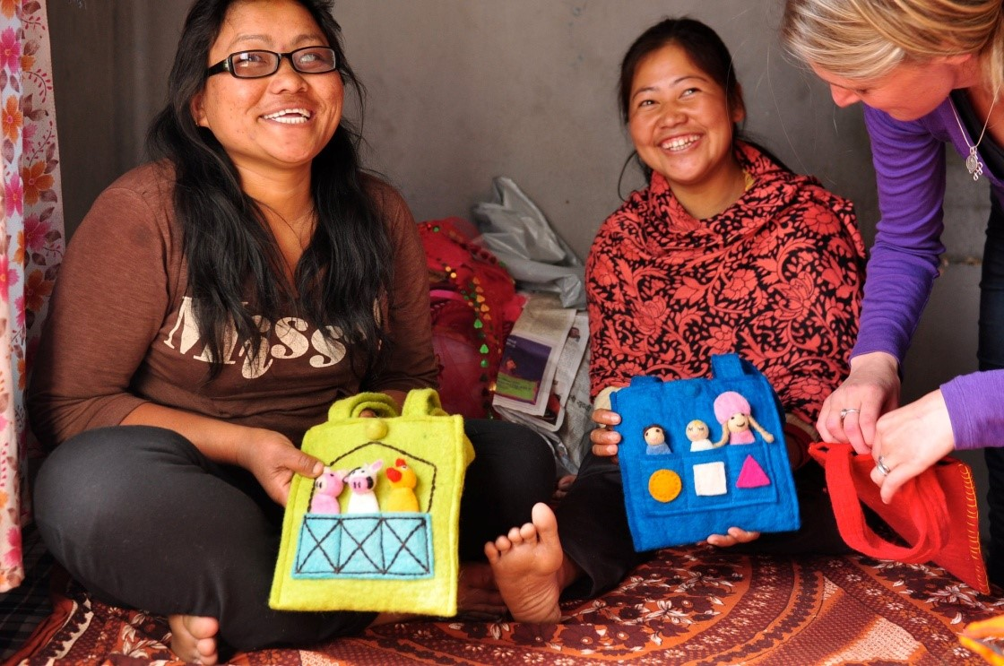

# **Share your feedback**

**Let us know how it goes!**

We would love to hear how your event goes. Please drop us an email or let us know through social media. Email us at info@seven-women.com and give us your feedback as well as any photos you take so we can promote your event on social media!

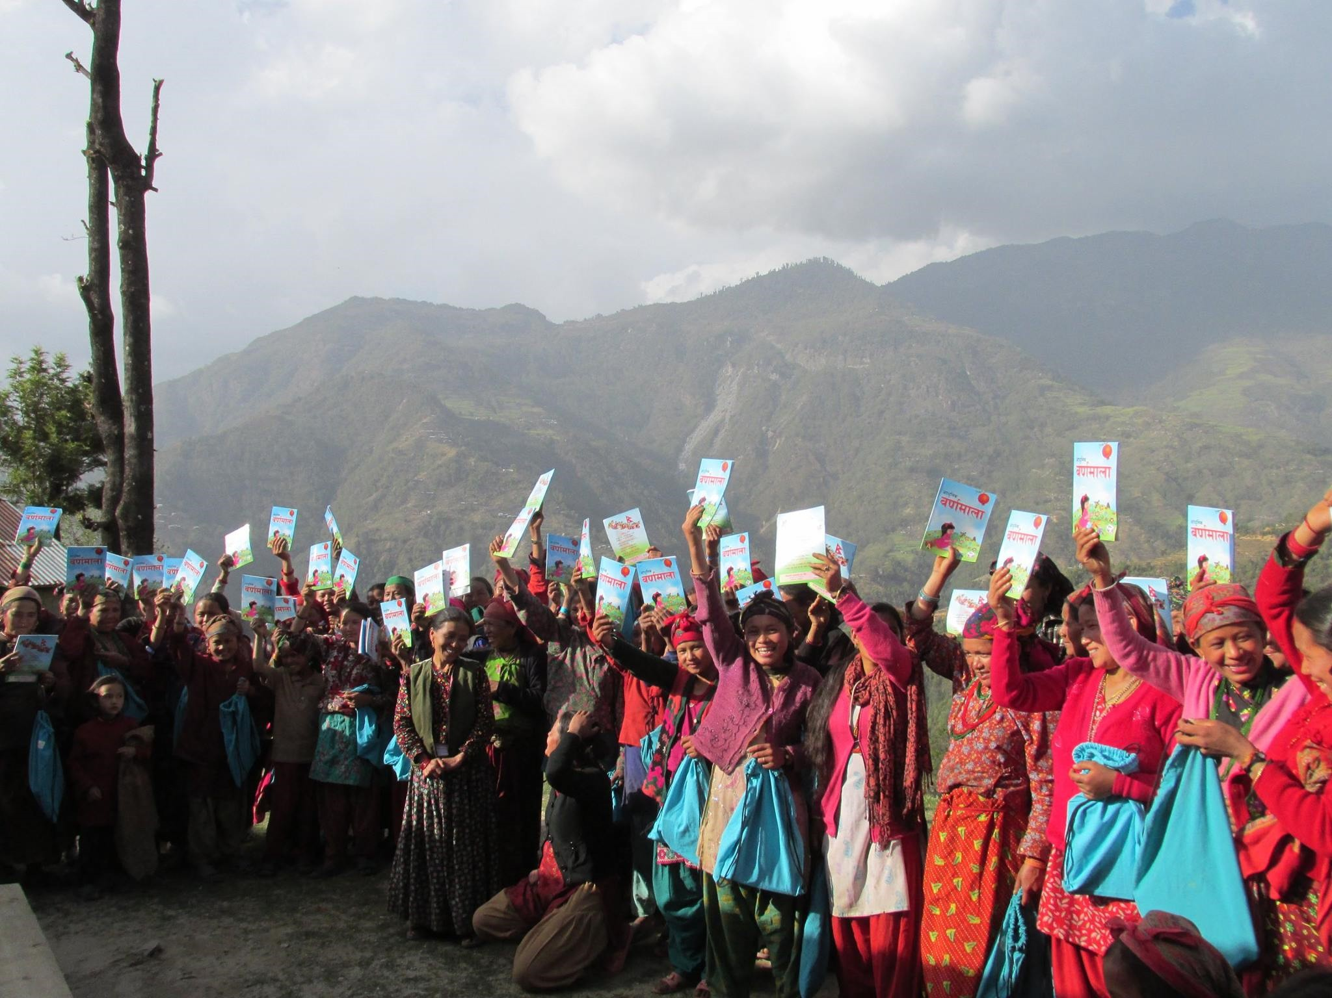

**EXAMPLE Seven Women Documentary Running Sheet**

5:15 - Cinema Set up commences

- Set up Registration and Sales Tables

* Place Seven Women flyers on all chairs

5:45 - Guests arrive

- Food and drink commences

6:20 - Cinema opens guests are seated

6:30 - Welcome and introductions by MC

6:35 - Seven Women Documentary

7:30 - Film Ends

7:35 - MC comments and opens floor to Q&A (3 microphones required)

8:00 - Closing comments

8:15 - Goodbyes, leave cinema

**Volunteers’ Tasks**

1. Set up registration and sales tables
2. Welcoming guests
3. Marking off names on door
4. VIP Minders
5. Handing out microphones during Q&A
6. Signing up sponsorships after Q&A